**AI Enemy**

**Chase Player**

<https://www.youtube.com/watch?v=zNJEvAGiw7w&list=PL4G2bSPE_8ukuajpXPlAE47Yez7EAyKMu>

1. Create a new sequence
2. Rename it to ChasePlayer.
3. Connect it as another branch of the selector
4. 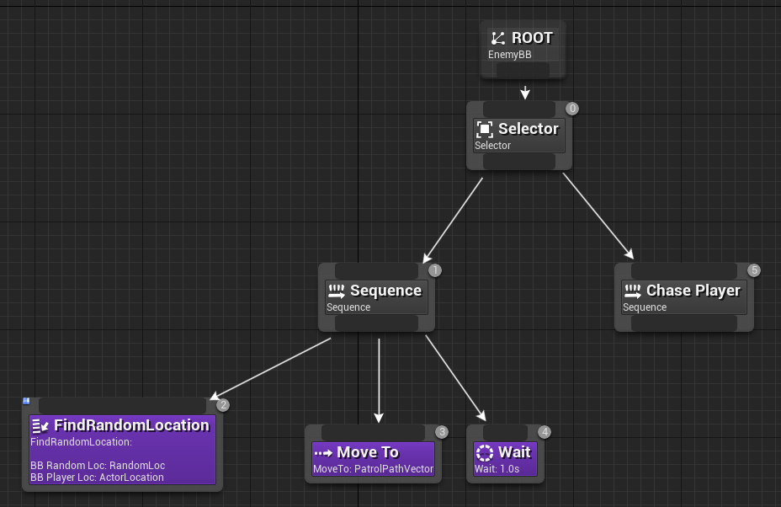
5. In Blackboard create a vector variable called “ActorLocation”
6. Create new Task.
7. Rename the task in content browser “FindPlayer”
8. Create a variable of type blackboard key selector
9. Add Event Receive Execute AI and Finish Execute
10. 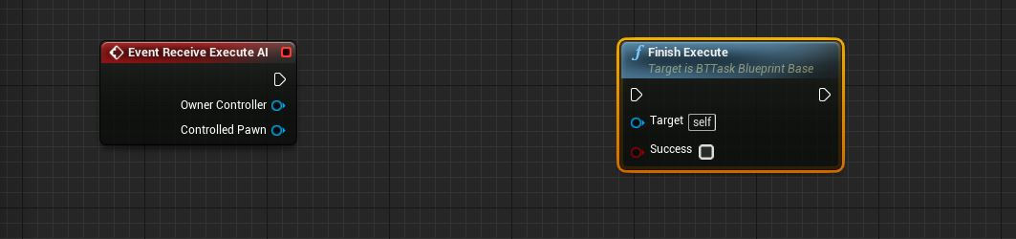
11. Add the following Blueprint
12. 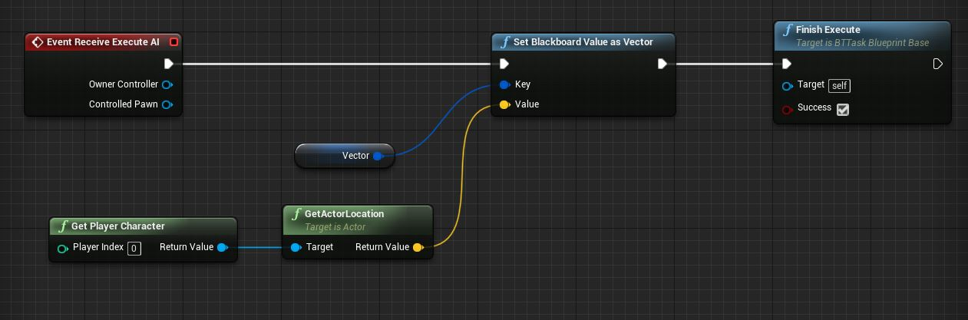
13. Add the new task, moveto and wait in Behaviour Tree under new sequence as follows
14. On FindPlayer and Moveto select the blackboard key as ActorLocation in details panel
15. 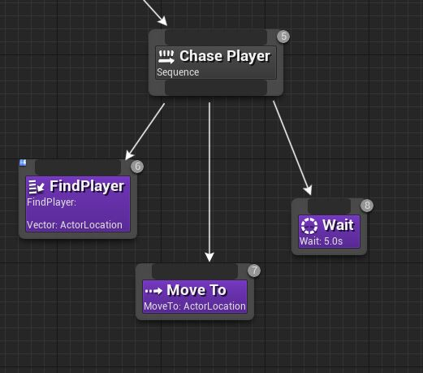
16. To decide if the enemy has found the player we need a boolean (to switch between 2 sequences)
17. For that create a boolean in Blackboard "CanSeePlayer"
18. Now we will give the sequences a decorator. (which decides if we want to go to the sequence)
19. Right click on "Go to Random Loc" sequence and go to Add Decorator and select Blackboard.
    1. A blue decorator will appear on the sequence
20. Select it and in details panel change Key Query to "is not set" and Blackboard Key to "can see player"
    1. Basically, it says if blackboard key "can see player" is not set, only then do the sequence.
21. We can rename the decorator.
22. Add another decorator on the other sequence and set the opposite to the cant see decorator.
23. 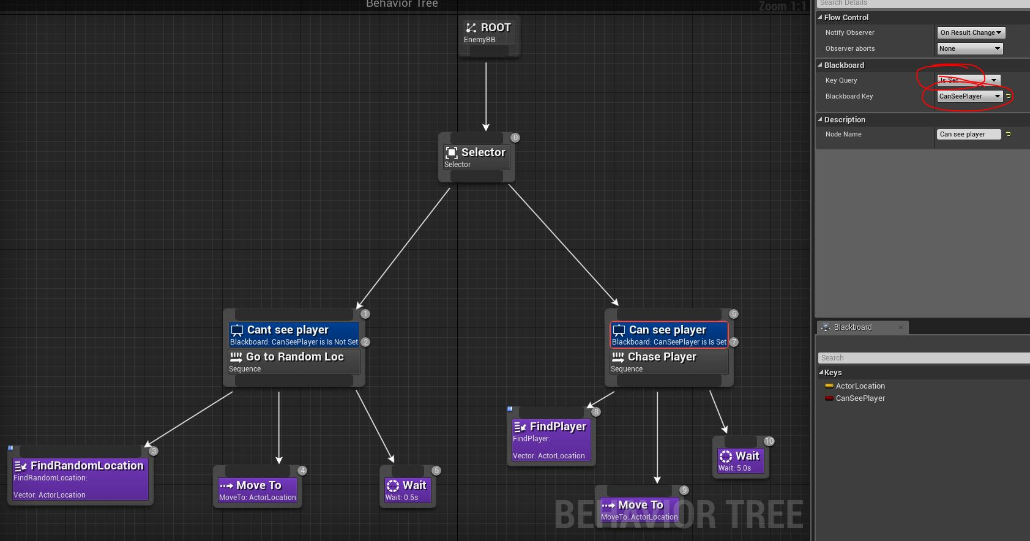
24. Now we need to set the boolean
25. For that go to AIController and add a component AIPerception
26. Select the AIPerception and Click the + sign to add a Senses Config
27. Change category to AI Sight Config
28. Open it and check all in Detections by affiliations
29. 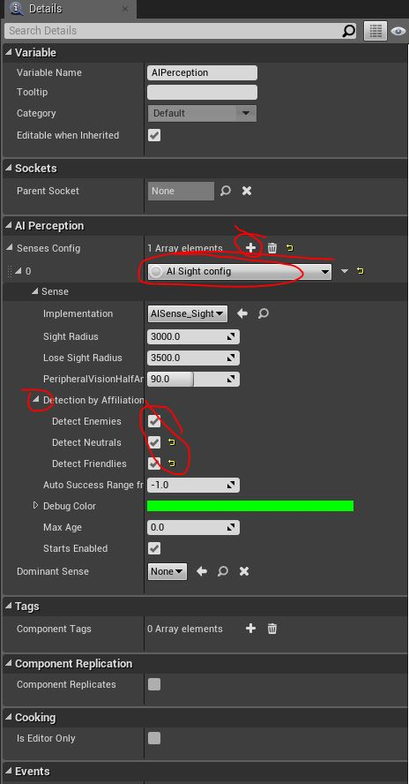
30. Now go to Player Character and add "AIPerceptionStimuliSource" component.
31. Go to its details and check auto register as source
32. Add array element
33. and select AISense_Sight in array element
34. 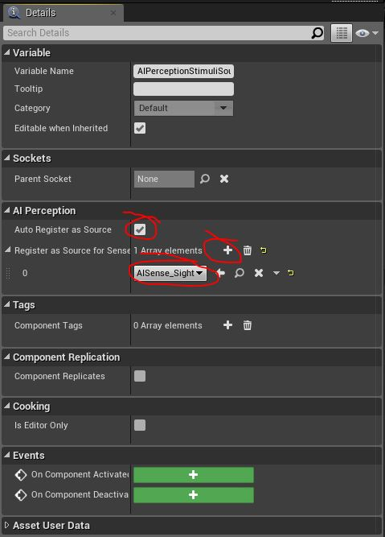
35. Now Go to AIPlayerController and select AIPerception and right click and search "OnTargetPerceptionUpdate" then add the following BPs
36. 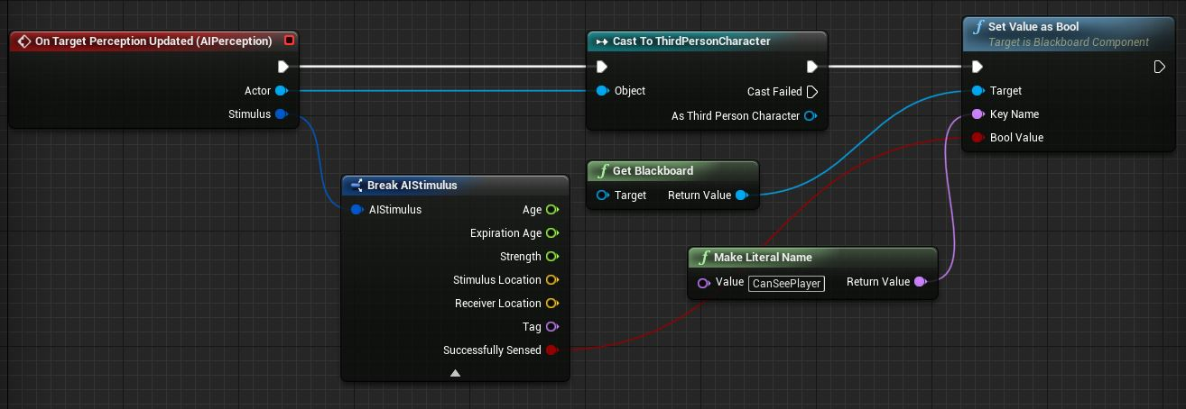
37. Compile and run and whenever the enemy see the player it will follow.
38. We can change the setting of AIPerception and AIPerceptionStimuliSource.
39. Try Cooldown decorator on chase player branch of Behaviour tree